TEMPLATE AND GUIDELINES FOR AUTHORS TO PREPARE FULL PAPERS FOR WORLD CONSTRUCTION SYMPOSIUM 2020 PROCEEDINGS [EXAMPLE OF STYLE ‘TITLE’]
Author One, Author Two and Author Three [Example of style ‘Authors’]
ABSTRACT [EXAMPLE OF STYLE ‘ABSTRACT HEADING’]
The author guidelines explain how to prepare your full paper for the “The 9th World Construction Symposium 2020”. It includes guidance on layout, illustrations, text style and references presented exactly as your paper should appear, so that its appearance is clear and consistent with the other papers in the proceedings. It is highly advised to use the template or strictly follow the instructions to prepare your paper in Microsoft Word. To ensure that your paper will conform to the required formatting, save this file with your paper’s title, and then write your text directly into it, erasing the contents as you go. The abstract portion is a narrative presentation without references. The abstract should give a brief and comprehensive summary of the purpose, methodology, findings and conclusions of the manuscript within 250 words. [Example of style ‘Abstract Text’]
Keywords: Add up to 3-5 Words or Phrases to be Used in Indexing in Alphabetical Sequence, Capitalising Each Word, Separated by a Semicolon (;) and Finishing with a Full-stop.

INTRODUCTION [example of style ‘heading 1’]
The guidelines for authors are designed to achieve uniformity in the papers appearing in the symposium proceedings. The typography, layout and styles stipulated in here must be strictly followed when preparing your document. These guidelines have been prepared as a MS Word Template and are available on the symposium web.
The official language of the symposium and proceedings is English; both UK English and American English are acceptable, but please select one and use it consistently in your paper. [Example of style ‘Paper body text’ for paragraph text]

CONTENT and structure
Your paper should be divided into sections, each with a heading, so that the reader can follow the logical development of work. Papers will typically start with an introduction and end with conclusions. The introduction should start immediately following the keywords (on the first page if possible). The conclusions must be followed by acknowledgments, if any, and then references.
The first page of the paper should provide the following:
- The title of the paper
- Author(s) name(s) [Important: Refer section 7.1 on anonymising author names for initial submission]
- Abstract (up to 250 words)
- Up to 05 keywords (Please spell ‘keywords’ as one word)
- Each author’s affiliation and e-mail address provided as footnotes

Length of Manuscript [Example of Style ‘Heading 2’]
The length of your paper should not exceed twelve pages including references. Prepare your paper in A4 size (21 cm x 29.7 cm). Please do not change the paper size and pre-defined styles.

Formatting Requirements
Papers submitted to World Construction Symposium should not only be academically sound and well written, but also be formatted properly. It is strongly advised that the authors use this WCS2020_Full Paper Template (.dotx) in formatting their papers. The next sections detail the formatting requirements of papers submitted to the symposium.

Document File Type
Please prepare and submit your paper as a MS Word document (.doc or .docx file extension). Submissions made using other file types will not be accepted.
The editors of the conference proceedings reserve the right to make minor editorial changes to papers in line with the guidelines specified here in order to make the papers better suited for printing.

Page Setup
Use the page setup requirements used in this template. This template has been prepared using A4 size (21 cm x 29.7 cm), with 3 cm margins. Do not change the headers/footers, page numbers or any other page setup guidelines.

Font Types, Styles and Sizes
Please use Times New Roman only. The font sizes and font styles are associated with the pre-defined Styles. Use only the styles defined in this template. Do not manually set font types, sizes or any other characteristics. Use the pre-defined styles properly and do not modify or update the styles in this template.

Heading Styles [Example of Style ‘Heading 3’]
Heading styles, other than ‘Title’ and ‘Abstract Heading’, have been left aligned. Sections and sub-sections are numbered using Arabic numerals.
The following heading styles are used:
- Title (used only for the paper title)
- Abstract Heading (used only for the abstract heading)
- Heading 1
- Heading 2
- Heading 3
Avoid using further subheadings.

Figures and Tables
Figures and tables should be centred on page. All tables and figures should be referred within the text and follow the paragraph in which it is first mentioned. The captions of each table and figure should fit within the same page as the table or figure it refers to.
- Figures
It is advisable to use Calibri or a similar sans-serif font in Figures. Figure caption should be placed below the figure, centred on page using style ‘Figure Caption’ as shown in Figure 1.
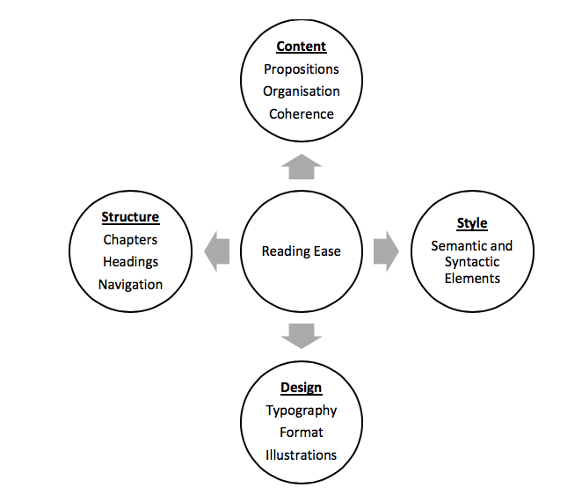
Figure 1: Four Basic Elements of Reading Ease [Example of style ‘Figure Caption’]
Drawings constructed as lines, boxes, text, etc. within MS Word cannot be reproduced effectively. Hence, it is preferred that figures in the paper use one of the following file types: Joint Photographic Experts Group (using file extension .jpg or .jpeg), Portable Network Graphics (.png), and bitmaps (.bmp).
Colours may be used in Figures; however, authors must ensure that the content is readable.
When a figure is inserted in the text, make sure the figure’s wrapping style is ‘In line with text’ and NOT ‘Behind text’ or “In front of text’.
- Tables
Tables should be centred on page. should be formatted using the styles ‘Table body’ and ‘Table headings’. Tables should have a thick (i.e. 2¼ pt) top border and a thin (i.e. ½ pt) bottom border. A thin (i.e. ½ pt) border should be under the header raw as well. Table captions should be placed above the table, centred on the page, using, the style ‘Table Caption’ as indicated in Table 1. If possible, keep tables to one page.
Table 1: Styles Used in This Template [Example of Style ‘Table Caption’]
Style Name | Usage
Title | Paper title
Authors | Author names
Abstract Heading | Abstract heading only
Abstract Text | Abstract text and keywords
Paper Body Text | All body text paragraphs of the paper
Heading 1 | First level headings of the paper
Heading 2 | Second level headings of the paper
Heading 3 | Third level headings of the paper
Table Headings | Headers of tables
Table Body | Content of tables
WCS List Bullet | For bulleted lists
WCS Numbered List | For numbered lists
Table Caption | For table captions
Figure Caption | For figure captions
Footnotes | For author affiliations on page 1
References | List of references

Abbreviations and Acronyms
Define abbreviations and acronyms the first time they are used. Do not use abbreviations in the titles unless unavoidable.

Units
Use the International System of Units (SI) only.

Equations
Number equations consecutively with equation numbers in parentheses. Italicise symbols for quantities and variables. Be sure that the symbols in your equation have been defined before the equation appears, or their definitions follow the equation immediately.
f (x) = sin (a) + cos (b) (01)
where, a = variable one and b = variable two.

SUBMISSION
Please adhere to the submission deadlines and submit your paper via the submit my full paper link in the symposium website. By submitting your paper, you agree and accept the commitment that at least one of the authors will register and attend the symposium and present the paper. Each registered author/co-author can present no more than three (03) papers, unless another registered author/co-author fails to attend and requests an attending colleague to present the paper on his/her behalf.
Please proofread your paper for grammar and style before submission. The responsibility for detecting errors lies with the author.
If your paper is accepted, the author(s) are required to then prepare and submit a camera-ready version of their paper taking into consideration the reviewers’ comments. This revised camera-ready version that is submitted after reviews are received should include proper author names and descriptions.

REVIEW PROCESS
All the papers are sent to at least two referees for the purpose of double-blind review process. Note that referees receive either the hardcopy or the softcopy of the paper without author(s) name(s), affiliation and email address, and the acknowledgments, if any.
Based on the referees’ comments, the scientific committee chairs will take one of the following decisions:
- Accept without changes
- Accept subject to minor changes
- Accept subject to major changes
- Reject
The accepted papers should be presented at the symposium. Note that the accepted papers cannot be presented or published elsewhere without significant changes.

conclusions
This document provides the template and detailed guidance for authors on how to prepare the full papers. It is highly advised that the authors use this template and strictly follow the instructions provided. A paper that does not meet the requirements will be returned to the author(s) for revision or rejected altogether.
The organisers and editors of World Construction Symposium will greatly appreciate that you follow these guidelines.

acknowledgements
Organisers and editors of World Construction Symposium thank the authors in advance for following these guidelines diligently.

references
A list of references is required at the end of the paper. References must be according to the Harvard Referencing System. Citations in the text appear as name and date within parentheses (e.g., Schendel, 1999) and complete references are listed alphabetically at the end of the paper. When a cited work has three or more authors, use the form “Main Author et al., year”.
When reference is made to more than one work by the same author(s) published in the same year, identify each citation in the text in the following manner: (Schendel, 2005a, 2005b). Online citations should include the date of access. Please be sure to include complete references for databases, including the year, online addresses and access date.
Use the style ‘References’ in developing the reference list. Following are some examples of different types of references:
- For books
Mercer, P.A. and Smith, G., 1993. Private View data in the UK. 2nd ed. London: Longman.
- For journals
Evans, W.A., 1994. Approaches to Intelligent Information Retrieval. Information Processing and Management, 7(2), 147-168.
- Conference papers
Silver, K., 1991. Electronic Mail: The New Way to Communicate. In: Raitt, D.I. (ed). 9th International Online Information Meeting, London 3-5 December 1990. Oxford: Learned Information, 323-330.
- Thesis
Agutter, A.J., 1995. The Linguistic Significance of Current British Slang. Thesis (PhD). Edinburgh University.
- Web pages
Holland, M., 1996. Harvard System [online]. Poole, Bournemouth University. Available from: http://www.bournemouth.ac.uk/lis/LIS_Pub/harvard syst.html [Accessed 15 April 1996].

Department, University or Company, Country, E-mail
Department, University or Company, Country, E-mail
Department, University or Company, Country, E-mail

